**IREVOLUTION : A DATA – DRIVEN EXPLORATION OF APPLE’S IPHONE IMPACT IN INDIA**



1. INTRODUCTION :

1.1 OVERVIEW:

Designs, manufactures, and markets smart phone, tablets, personal computers, and wearable devices.

1.2 PURPOSE:

The I phone is a smart phone made by apple that combines a computer, I pod, digital camera and cellular phone into one device with a touch screen interface

2. PROBLEM DEFINITION & DESIGN THINKING:

* EMPATHY MAP
* BRAINSTORM

2.1 EMPATHY MAP:

* An empathy map is collaborative tool teams can use to gain a deeper insight into their customers.
* Register the MURAL website to create the map.
* In my term we are discussed and collect the details.

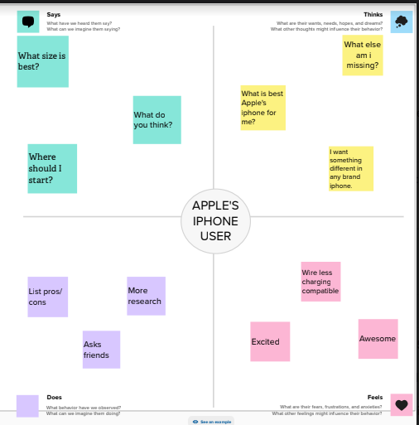

2.2 IDEATION & BRAINSTROMING MAP:

* Brainstorming is a larger or small group discussion that encourages students to generate a wide range of perspective or

Potential next steps or solution reading a specific topic.

* Use MURAL website to create .

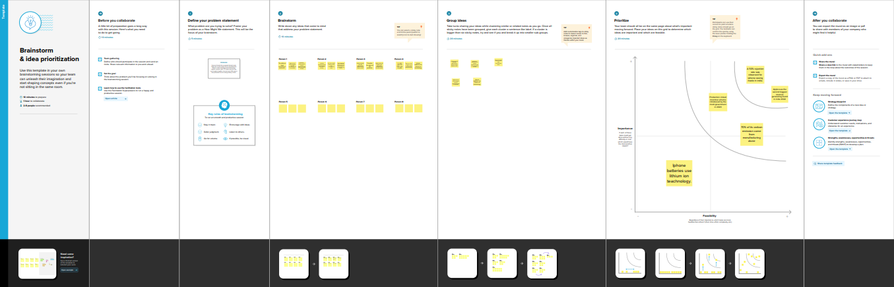

3. RESULT:

* Collect the Dataset.
* Dataset connect with TABLEAU.

COLLECT THE DATASET:

* We are collect the dataset in online.

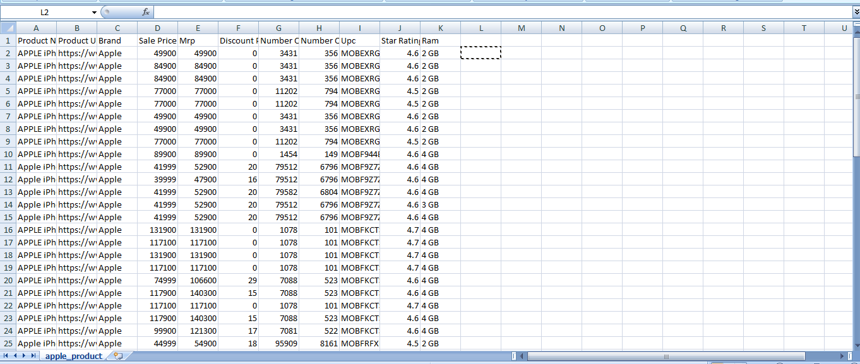

DATASET CONNECT WITH TABLEAU:

* Installed the tableau destop.
* Insert the dataset in tableau.

DATA PREPARATION:

* Prepare the data for visualization.
* We give some changes for the dataset.

DATA VISUALZATION:

* KPI
* Product URL
* Battery Type Distribution
* Brand Price Comparision
* Model-Share
* URL Sales price
* Star Rating

DASHBOARD:

* A Dashboard is a graphical user interface (GUI) that displays information and data in an organize.
* Combine two or more sheets create a dashboard.

DASHBOARD 1:

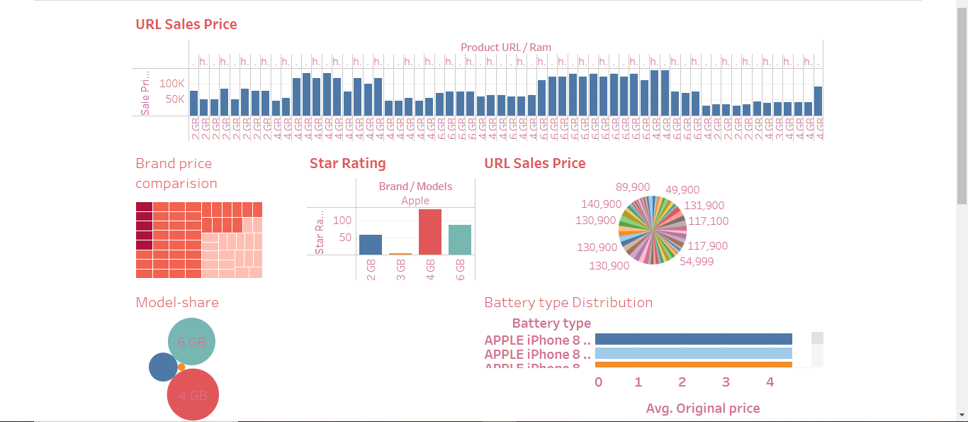

DASHBOARD 2: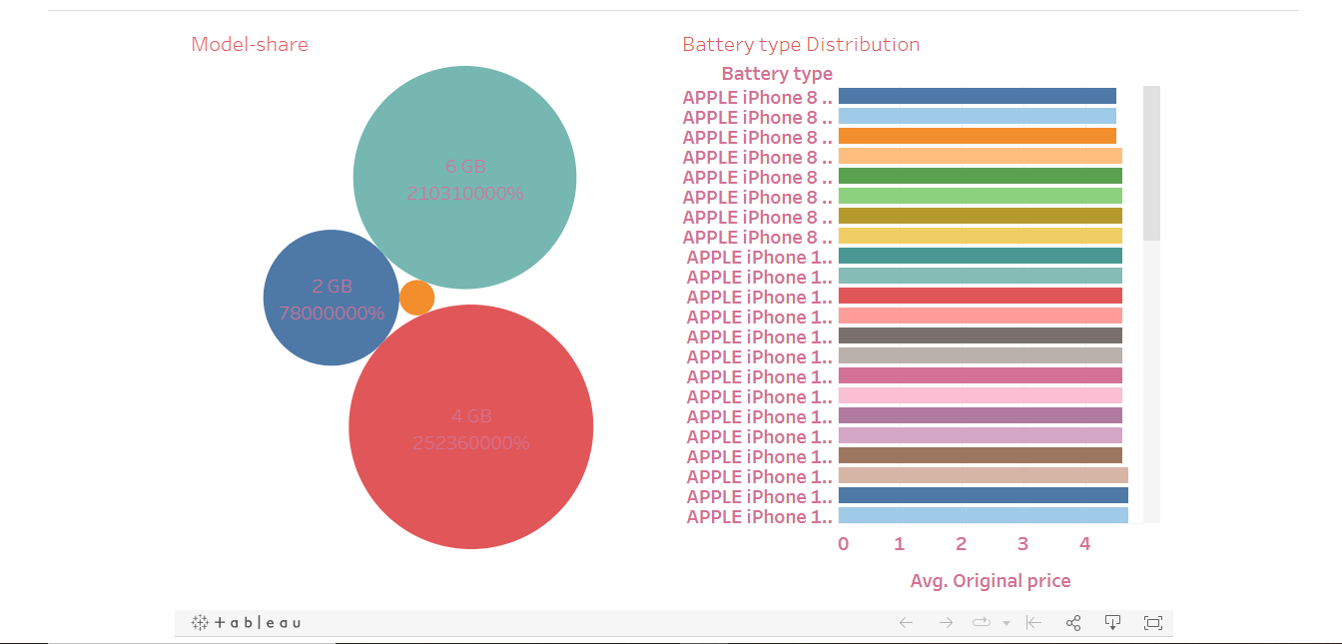

DASHBOARD 3:

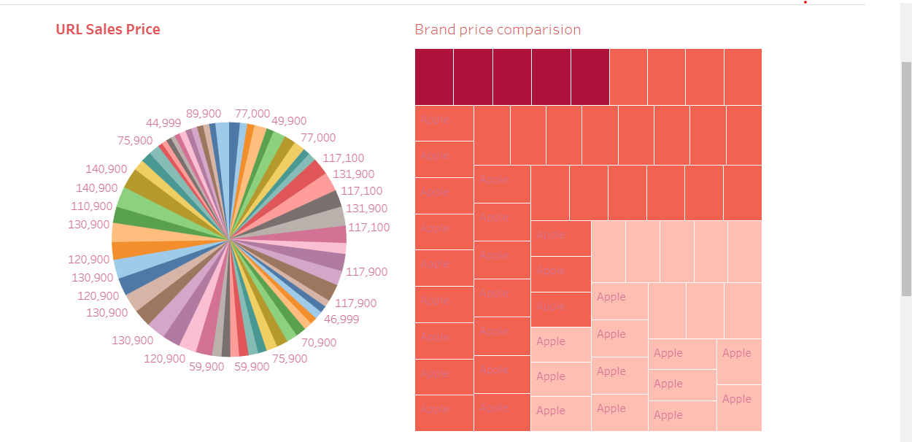

DASHBOARD 4:

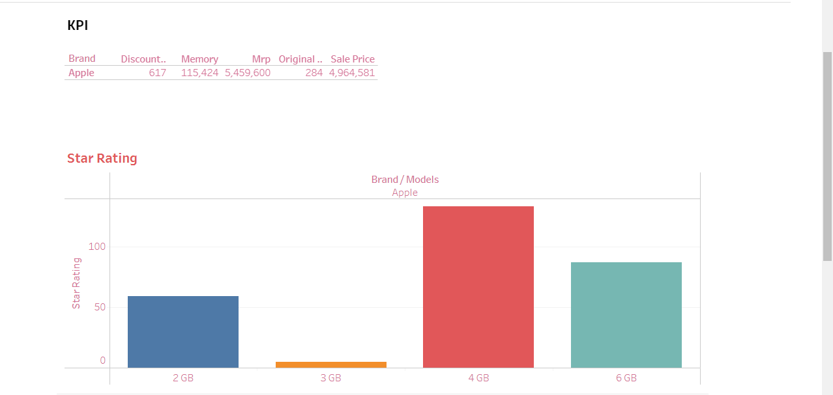

DASHBOARD 5:

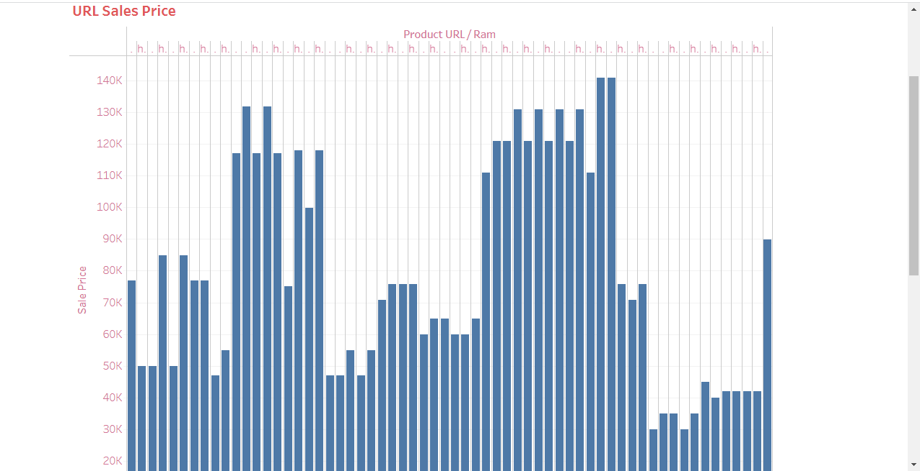

STORY :

* A data story is a way of presenting data and analysis in a narrative format, with the goal of making the information more engaging and easier to understanding.

STORY CREATION:

1. Create story point.
2. Explore layout options.
3. Format a story.
4. Resize captions.
5. Fit the sheets are one by one.
6. Format a story’s shading, title, and text objects.

STORY 1: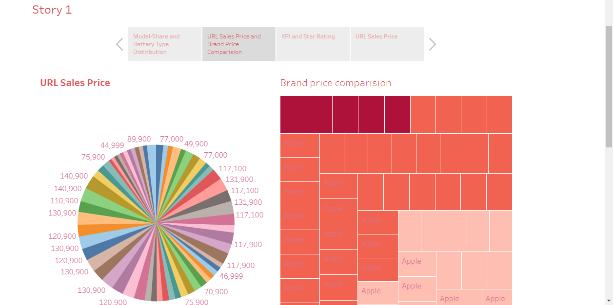

PUBLISHING:

* Publishing helps us to track and monitor key performance metrics, to communicate results and progress help a publisher stay informed, make better decisions, and communicate their performance to others.

PUBLISHING DASBOARS AND REPORTS TO TABLEAU PUBLIC:

STEP 1: Go Dashboard/story, click on share button on the top ribbon. Give the server address of your tableau public account and click on connect.

SERVER ADDRESS : Public.tableau.com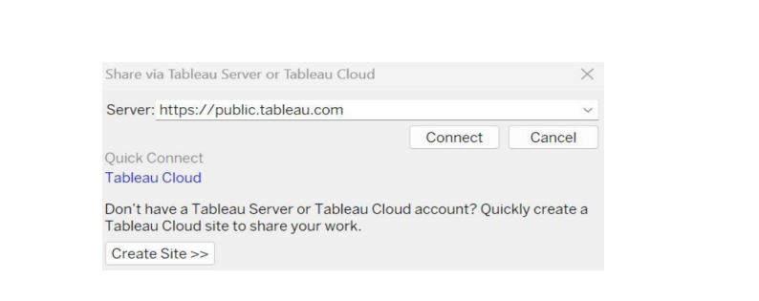 STEP 2 : Once you click on connect it will ask you for tableau public user name and password.

Once you login into your tableau public using the credentials, the particular visualization will be published into tableau public.

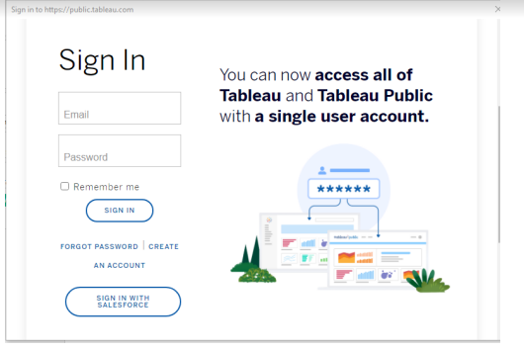

4. ADVANTAGES & DISADVANTAGES:

ADVANTAGES:

* The ipone has many advantages. For which users do not want to shift to other brands of devices.
* Notable among these are long time software update facility, security, eye – catching design, performance.
* Below are some more fearures and benefits of the ipone was highlighted.

DISADVANTAGES:

* Cost : The ipone is one of the most expensive smartphones on the market.
* Non-Removable Battery: The ipone’s batteries aree non-removable, which means that user cannot replace them.
* Limited Customization : One of the disadvantages of the ipone is that it has limited customization options.

5. APPLICATIONS:

* An iphone app is an application, typically developed by a company other than Apple, and designed to be used specifically on the iphone or ipod touch.
* Apps work much like user – installed software on a computer and allow the phone to perform specific tasks that the user wants or needs.

6.CONCLUSION:

* Apple and iphone is a great example of a corporation making what the consumer wants in global market.
* With limited companies competing, competition for the best phone on the market is at an all-time high.

7.FUTURE SCOPE:

* But in the future, the most important part of the iphone might everything around it.
* That’s according to analysts who’ve observed the mobile industry’s general trends and Apple’s str

DASHBOARD 1:

<https://public.tableau.com/views/Dashboard1_16964835157990/Dashboard1?:language=en-US&publish=yes&:display_count=n&:origin=viz_share_link>

DASHBOARD 2:

<https://public.tableau.com/views/Dashboard2_16964839268250/Dashboard2?:language=en-US&publish=yes&:display_count=n&:origin=viz_share_link>

DASHBOARD 3:

<https://public.tableau.com/views/Dashboard3_16966665755080/Dashboard3?:language=en-US&publish=yes&:display_count=n&:origin=viz_share_link>

DASHBOARD 4:

<https://public.tableau.com/views/Dashboard4_16966670467630/Dashboard4?:language=en-US&publish=yes&:display_count=n&:origin=viz_share_link>

DASHBOARD 5:

<https://public.tableau.com/app/profile/kanimozhi.g5758/viz/Dashboard5_16966672328350/Dashboard5?publish=yes>

STORY:

<https://public.tableau.com/shared/RWW5SM6RX?:display_count=n&:origin=viz_share_link>